KAARKUN: An AI-Powered Multi-Platform Service Marketplace

BY

ZAHEER ABBAS

Thesis Submitted to University of Swabi, Khyber Pakhtunkhwa, in partial fulfillment of the requirement for the degree of

BACHELOR OF SCIENCE IN COMPUTER SCIENCE



DEPARTMENT OF COMPUTER SCIENCE THE UNIVERSITY OF SWABI
KHYBER PAKHTUNKWA, PAKISTAN SESSION (2022-2026)

KAARKUN: An AI-Powered Multi-Platform Service Marketplace

By

ZAHEER ABBAS

Thesis Submitted to University of Swabi, Khyber Pakhtunkhwa, in partial fulfillment of the requirement for the degree of

BACHELOR OF SCIENCE IN COMPUTER SCIENCE

Approved by:

Chairman Supervisory Committee
Dr. Shah Nazir

Co-Supervisor [Field/ Research/ Lab]
Prof. Hammad

Chairman Department of Computer Science
Prof. Mushtaq Ali Shah

DEPARTMENT OF COMPUTER SCIENCE THE UNIVERSITY OF SWABI
KHYBER PAKHTUNKWA, PAKISTAN
SESSION (2022-2026)

KAARKUN: An AI-Powered Multi-Platform Service Marketplace

CERTIFICATE OF SIGNATORY PAGE OF FOREIGN EVALUATORS / EXTERNAL EVALUATORS (PAKISTAN)

External Evaluators / Examiners for Thesis Evaluation

External Examiner-1

To be approved by the Vice Chancellor

To be approved by the Vice Chancellor
External Examiner-2

External Examiner-3

To be approved by the Vice Chancellor

KAARKUN: An AI-Powered Multi-Platform Service Marketplace

Examiners for Thesis Viva Voce

Dr. Shah Nazir External Examiner

Chairman Supervisory Committee

Prof. Mushtaq Ali Shah
Head Of Department Of Computer Science

PAGE FOR CERTIFIACTE OF TEST REPORT OF PLAGIARISM TO BE OBTAINED FROM QEC

SIMILARITY INDEX CERTIFICATE FOR THESIS

Approved Title by ASRB: KAARKUN: An AI-Powered Multi-Platform Service Marketplace

Department: DEPARTMENT OF COMPUTER SCIENCE, THE UNIVERSITY OF SWABI

Submitted by: ZAHEER ABBAS

Supervisor: Prof. HAMMAD
DEPARTMENT OF COMPUTER SCEINCE THE UNIVERSITY OF SWABI

Submission ID: 2753350718

Similarity Index: 5%

CHECKED BY
Prof. HAMMAD

COUNTER SIGNED BY QEC

Director QEC University of Swabi, KP

TABLE OF CONTENTS
__________________________________________________________________________________________
CHAPTER TITLE PAGE NO
__________________________________________________________________________________________

TABLE OF FIGURES…………………………………………………………................IX
TABLE OF IMAGES ……………………………………………………………………..X
LIST OF TABLES …………………………………………………………………………XI
LIST OF ABBREVIATIONS ……………………………………………………………XII
ACKNOWLEDGMENTS………………………………………………………………..XIII
ABSTRACT………………………………………………………………………………..14
CHAPTER-1
1. INTRODUCTION..........................................................................................................…...15
1.1 PROJECT OVERVIEW / BACKGROUND…………………………….................15
1.1.2 PROBLEM STATEMENT…………………………………………………15
1.1.3 RESEARCH OBJECTIVES………………………………………………...16
1.2 PROJECT SCOPE…..................................................................................................16
1.3 TOOLS AND TECHNOLOGIES…………………………………………………...16
1.3.1 SOFTWARE………………………………………………………………..16
1.3.2 TECH STACK……………………………………………………………...17
1.3.3 HARDWARE……………………………………………………………....17
1.4 LIMITATIONS OF KAARKUN…………………………………………………..17
1.5 OUTLINE OF THESIS…………………………………………………………….17
CHAPTER-2
2. REVIEW OF LITERATURE ……………………………………………………………...19
2.1 PLATFORM ECONOMY OVERVIEW…………………………………………..19
2.2 DIGITAL SERVICE PLATFORMS IN SOUTH ASIA…………………………...19
2.3 PAKISTAN DIGITAL ECONOMY……………………………………………….19
2.4 MOBILE AND WEB TECHNOLOGIES FOR SERVICE MARKETPLACES…..20
2.5 COMPARISON WITH EXISTING PLATFORMS……………………………….20
2.6 RESEARCH GAP…………………………………………………………………20
CHAPTER-3
3. MATERIALS AND METHODS………………………………………………………….22
3.1 RESEARCH METHODOLOGY (DSR) …………………………………………22
3.2 SYSTEM ARCHITECTURE DIAGRAM………………………………………..22
3.3 FUNCTIONAL REQUIREMENTS………………………………………………23
3.4 USE CASE ANALYSIS…………………………………………………………..24
3.5 DATABASE DESIGN (ERD DIAGRAM) ………………………………………25
3.6 IMPLEMENTATION FEATURES……………………………………………….27
3.6.1 AUTHENTICATION AND AUTHORIZATION.………………………...27
3.6.2 JOB POSTING, BIDDING, AND BOOKING…………………………….27
3.6.3 QR CODE VERIFICATION……………………………………………….27
3.6.4 REAL-TIME MESSAGING AND GPS TRACKING……………………..27
3.6.5 AI CHATBOT………………………………………………………………27
3.6.6 ADMINISTRATION PANEL………………………………………………27
3.6.7 WALLET AND TRANSACTION SYSTEM……………………………….28
3.6.8 MULTILINGUAL AND MULTI-CURRENCY INTERFACE………….,,,,29
3.7 PROJECT SCREENSHOTS………………………………………………………29
3.8 SECURITY DESIGN……………………………… ……………………………..32
3.9 DEPLOYMENT ARCHITECTURE AND DEVOPS PIPELINE……………….36
3.9.1 CONTINUOUS INTEGRATION AND DELIVERY (CI/CD)………….36
3.9.2 DOCKER CONTAINER ARCHITECTURE …………………………….36 3.9.3 AWS CLOUD INFRASTRUCTURE……………………………………..37
3.9.4 NETWORK ARCHITECTURE AND SECURITY GROUPS……………37
3.9.5 INFRASTRUCTURE AS CODE (TERRAFORM)………………………..38
3.9.6 SECRET MANAGEMENT………………………………………………..38
3.9.7 DEPLOYMENT FLOW SUMMARY……………………………………..38
3.10 USER INTERFACE DESIGN REFINEMENTS…………………………………..39
3.10.1 ADMINISTRATION PANEL ENHANCEMENTS……………………….39
3.10.2 FLUTTER MOBILE APPLICATION REFINEMENTS………………….39
3.10.3 WEB FRONTEND NAVIGATION REFINEMENTS………………………40
CHAPTER-4
4. RESULTS AND DISCUSSION…………………………………………………………..41
4.1 TESTING APPROACH…………………………………………………………...41
4.2 FUNCTIONAL TESTING RESULTS……………………………………………42
4.3 INTEGRATION TESTING RESULTS…………………………………………..42
4.4 REQUIREMENTS COMPLIANCE MATRIX…………………………………...43
4.5 DISCUSSION ……………………………………………………………………..43
CHAPTER-5
5. SUMMARY……………………………………………………………………………….45
CHAPTER-6
6. CONCLUSION AND RECOMMENDATIONS………………………………………….46
6.1 CONCLUSION……………………………………………………………………46
6.2 RECOMMENDATIONS………………………………………………………….46
LITERATURE CITED……………………………………………………………48
SHORT BIOGRAPHY OF THE SCHOLAR……………………………………..50

TABLE OF FIGURES

FIGURE NO TITLE PAGE NO

FIGURE 3.1 KAARKUN SYSTEM ARCHITECTURE DIAGRAM………………….23
FIGURE 3.2 ENTITY-RELATIONSHIP DIAGRAM (ERD) — 11 TABLES………...26
FIGURE 3.3 USE CASE DIAGRAM: CUSTOMER ACTOR…………………………25
FIGURE 3.4 USE CASE DIAGRAM: SERVICE PROVIDER ACTOR………………26

TABLE OF IMAGES

IMAGE NO TITLE PAGE NO

IMAGE 3.1 KAARKUN APP — CUSTOMER HOME SCREEN……………………30
IMAGE 3.2 KAARKUN APP — POST A JOB SCREEN…………………………….30
IMAGE 3.3 KAARKUN APP — PROVIDER BID SCREEN………………………...31
IMAGE 3.4 KAARKUN APP — QR CODE VERIFICATION SCREEN……………31
IMAGE 3.5 KAARKUN APP — REAL-TIME GPS TRACKING SCREEN………...32
IMAGE 3.6 KAARKUN APP — IN-APP CHAT SCREEN…………………………..32
IMAGE 3.7 KAARKUN APP — PROVIDER PROFILE SCREEN…………………..33
IMAGE 3.8 KAARKUN ADMIN PANEL — USER MANAGEMENT……………...33
IMAGE 3.9 KAARKUN ADMIN PANEL — PROVIDER VERIFICATION………..34
IMAGE 3.10 KAARKUN ADMIN PANEL — DASHBOARD OVERVIEW…………34

LIST OF TABLES

TABLE NO TITLE PAGE NO

TABLE 1.1 SCOPE AND LIMITATIONS OF KAARKUN..................16
TABLE 2.1 COMPARATIVE ANALYSIS OF SERVICE MARKETPLACE PLATFORMS.20
TABLE 3.1 KAARKUN FUNCTIONAL REQUIREMENTS...................23
TABLE 3.2 SECURITY MEASURES BY SYSTEM LAYER.................35
TABLE 4.1 FUNCTIONAL TEST CASE RESULTS......................41
TABLE 4.2 INTEGRATION TEST SCENARIOS........................42
TABLE 4.3 RESEARCH OBJECTIVES COMPLIANCE MATRIX.............43

LIST OF ABBREVIATIONS

ABBREVIATION | FULL FORM
AI | Artificial Intelligence
API | Application Programming Interface
ASRB | Advanced Studies and Research Board
BCrypt | Password-Hashing Algorithm (Blowfish)
CORS | Cross-Origin Resource Sharing
DSR | Design Science Research
ERD | Entity-Relationship Diagram
FK | Foreign Key
GPS | Global Positioning System
HTTP | Hypertext Transfer Protocol
HTTPS | Hypertext Transfer Protocol Secure
JWT | JSON Web Token
KP | Khyber Pakhtunkhwa
MySQL | My Structured Query Language
NLP | Natural Language Processing
PK | Primary Key
QR | Quick Response
REST | Representational State Transfer
SDK | Software Development Kit
UI | User Interface
UX | User Experience
WS | WebSocket

ACKNOWLEDGMENTS
In the name of ALLAH, the Most Gracious and Most Merciful, all praises be to ALLAH for the strength and blessings He has bestowed upon me throughout the completion of this project. I am deeply grateful to Almighty ALLAH, whose guidance and mercy have been my constant companion.
I would like to express my profound and sincere gratitude to my supervisor, Prof. Hammad, Department of Computer Science, The University of Swabi, for his exceptional guidance, continuous encouragement, and invaluable support throughout every phase of this project. His insightful suggestions, constructive feedback, and unwavering dedication to academic excellence have been the driving force behind the successful completion of this thesis.
I am deeply thankful to Dr. Shah Nazir (Chairman Supervisory Committee) and Prof. Mushtaq Ali Shah (Chairman, Department of Computer Science) for their scholarly guidance and oversight. I also extend my appreciation to all faculty members of the Department of Computer Science, The University of Swabi, whose teachings and academic support laid the foundation for the technical skills applied in this project.
I am grateful to my family for their endless patience, moral support, and encouragement during the long hours devoted to this project. Their belief in my abilities has been a constant source of motivation. I also thank my fellow classmates and colleagues who offered their assistance, feedback, and encouragement throughout this journey.
Finally, I dedicate this thesis to all the skilled workers and service seekers of Khyber Pakhtunkhwa whose daily challenges inspired the design and development of the Kaarkun platform.

ZAHEER ABBAS

ZAHEER ABBAS AND PROF. HAMMAD
DEPARTMENT OF COMPUTER SCIENCE, THE UNIVERSITY OF SWABI,
ANBAR-SWABI, KHYBER PAKHTUNKHWA, PAKISTAN
JULY 2026

ABSTRACT

Kaarkun is an AI-powered, multi-platform service marketplace designed to connect customers with verified skilled service providers in Khyber Pakhtunkhwa, Pakistan. The platform addresses five structural problems of the informal domestic service sector: discoverability gap, absence of verified credentials, price opacity, communication gap, and lack of accountability. The system comprises a Flutter mobile application serving both customers and providers on Android and iOS, a Next.js customer web application, a Next.js administration panel, and a Node.js/Express.js REST API backend connected to a MySQL 8.0 relational database of eleven tables. Real-time features are delivered through Socket.io WebSocket connections for in-app messaging and live GPS tracking. Key functional innovations include a transparent competitive bidding system allowing multiple verified providers to bid on customer-posted job requests, a QR code-based booking verification mechanism that generates unique tokens on bid acceptance and records timestamped check-in and check-out events, real-time GPS location tracking enabling customers to monitor provider movement on a Google Maps interface, an on-device rule-based AI chatbot for instant platform guidance, and a comprehensive administrator panel for credential verification and platform governance. The system was designed using the Design Science Research (DSR) methodology and implemented through Agile two-week sprints. Security measures include JWT-based authentication, bcrypt password hashing, parameterised SQL queries, CORS restrictions, and file upload validation. System evaluation through 25 functional black-box test cases and 5 integration test scenarios achieved a 100% pass rate, confirming that all 20 functional requirements and all 5 research objectives were fully satisfied. Kaarkun demonstrates that a production-quality multi-platform service marketplace incorporating AI assistance, real-time communication, and GPS tracking can be designed and implemented using open-source technologies within an academic project context.

CHAPTER-I
INTRODUCTION
1.1 Project Overview / Background
The global platform economy has fundamentally transformed the way consumers access services and how workers secure employment. Digital service marketplaces such as Uber, TaskRabbit, and Urban Company have demonstrated that multi-sided platforms connecting service seekers with service providers can generate substantial economic value while simultaneously improving efficiency, price transparency, and accountability for both parties. These platforms create value by reducing search costs, providing structured trust mechanisms through ratings and identity verification, and enabling direct communication between parties that would otherwise rely on informal networks.
In Pakistan, the informal skilled-trade and domestic service sector represents a significant portion of the labour market. Millions of plumbers, electricians, carpenters, painters, and household cleaners operate without formal registration, without digital presence, and without any platform through which customers can locate, evaluate, or engage their services. Customer-provider matching occurs entirely through word-of-mouth referrals, which limits geographic reach, excludes newcomers from the market, and provides no mechanism for verifying provider credentials or holding either party accountable for service outcomes.
Khyber Pakhtunkhwa (KP), Pakistan, presents a particularly acute version of this problem. Despite rapid growth in mobile internet penetration and smartphone adoption, no locally developed platform specifically targets the KP domestic service market. Existing national or international platforms either operate only in major metropolitan centres such as Karachi and Lahore, or lack the language, cultural, and economic adaptations necessary for effective adoption in KP. This gap represents a significant opportunity for a purpose-built digital marketplace that addresses local market conditions.
Kaarkun — derived from the Urdu/Pashto word for worker — is designed to fill this gap. It is a multi-platform AI-assisted service marketplace that connects customers with verified skilled service providers through a competitive bidding system, real-time communication tools, GPS-based location tracking, and a QR code attendance verification mechanism.
1.1.2 Problem Statement
Despite the scale and economic significance of the informal skilled labour market in Pakistan, several structural problems persist that reduce efficiency and trust for both customers and service providers:
Discoverability gap. Customers cannot efficiently locate skilled workers in their vicinity; workers cannot reach new customers beyond their existing social networks.
Absence of verified credentials. No mechanism exists for customers to verify a worker's qualifications, experience, or identity before engagement.
Price opacity. Service prices are set informally without reference to market rates, enabling exploitation of uninformed customers and undercutting of skilled workers.
Communication gap. Once a service is arranged, there is no structured channel for customer-provider communication, leading to missed appointments and unresolved misunderstandings.
Lack of accountability. There is no formal record of service delivery, no attendance verification mechanism, and no structured system for post-service feedback.
1.1.3 Research Objectives
The following five research objectives guided the design, development, and evaluation of the Kaarkun platform:
1. Design and implement a multi-platform service marketplace connecting customers with verified skilled service providers through a unified mobile and web interface.
2. Implement a transparent, competitive bidding system that allows multiple verified providers to bid on customer-posted job requests, replacing opaque informal price negotiation.
3. Provide real-time communication tools and GPS-based location tracking to improve service reliability and reduce information asymmetry between customers and providers.
4. Integrate an AI assistant chatbot for self-service platform guidance, accessible without a network connection.
5. Establish institutional trust mechanisms through verified identity screening, QR code-based attendance verification, and a structured peer review and rating system.
1.2 Project Scope
Table 1.1 presents the defined scope boundaries and acknowledged limitations of the Kaarkun system.
Table 1.1 — Scope and Limitations of Kaarkun
Scope (Included) | Limitation (Excluded)
Flutter mobile app (Android & iOS) | iOS App Store publication (development only)
Next.js customer web application | Desktop native application
Next.js administration panel | Multi-language UI (English only)
Node.js/Express.js REST API | Real payment gateway integration
MySQL 8.0 relational database | Production-grade load testing
Real-time chat via Socket.io | Third-party push notifications (FCM)
Live GPS tracking via Google Maps | IoT hardware integration
QR code check-in/checkout | Formal user study with real users
Rule-based AI chatbot | LLM-based conversational AI
Admin panel (user & booking management) | Multi-city/multi-country deployment
1.3 Tools and Technologies
The Kaarkun platform was built using a carefully selected set of software tools, frameworks, and hardware resources that together support the development of a production-quality, multi-platform service marketplace. The following sub-sections document the development environment, technology stack, and hardware configuration used throughout this project.
1.3.1 Software
The following software tools were used during development: Visual Studio Code (v1.89) as the primary code editor for backend and web development; Android Studio (Hedgehog edition) for Flutter mobile development and Android emulator management; Git (v2.44) and GitHub for version control and collaborative workflows; Docker Desktop (v4.29) for local containerised testing; Postman (v10) for REST API testing and documentation; MySQL Workbench (v8.0) for database schema design and query execution; and the AWS Management Console for cloud resource monitoring and ECS service management.
1.3.2 Tech Stack
The Kaarkun technology stack spans four tiers. (i) Client tier — Flutter 3.19 (Dart) for the cross-platform mobile application; Next.js 15 with TypeScript for both the customer web frontend and the administration panel. (ii) Server tier — Node.js 20 LTS with Express.js for the REST API; Socket.IO 4 for real-time WebSocket communication; and Multer-S3 for file uploads to Amazon S3. (iii) Data tier — MySQL 8.0 via the mysql2 driver for relational data; Amazon S3 for binary asset storage (avatars, job images, chat attachments). (iv) Infrastructure tier — Amazon Web Services (ECS Fargate, RDS, ALB, S3, ECR, Secrets Manager, CloudWatch, IAM); HashiCorp Terraform 1.8 for Infrastructure-as-Code; and GitHub Actions for CI/CD pipeline automation.
1.3.3 Hardware
Development was carried out on a Windows 11 Pro laptop equipped with an Intel Core i5 processor, 16 GB RAM, and a 512 GB SSD. The mobile application was tested on an Android Virtual Device (API level 33) and on a physical Android 13 smartphone. Production deployment runs on AWS Fargate in the ap-south-1 (Mumbai) region; each ECS task is allocated 0.5 vCPU and 1 GB memory. The production database is hosted on an Amazon RDS db.t3.micro instance with 20 GB General Purpose SSD storage.
1.4 Limitations of Kaarkun
Despite the breadth of features implemented, the Kaarkun platform has the following limitations within the scope of this Final Year Project: (i) The mobile application was developed and tested for Android only; iOS App Store publication requires a paid Apple Developer account that is outside the project budget. (ii) The wallet module does not integrate a live third-party payment gateway; top-up and withdrawal flows are implemented at the application level, but final settlement with JazzCash or EasyPaisa is deferred to a future release. (iii) The web frontend supports English only; Urdu localisation is available in the mobile app but has not been extended to the web. (iv) The system has not undergone production-grade load testing or formal security penetration testing. (v) No formal user study with real service seekers and providers in Khyber Pakhtunkhwa has been conducted within the scope of this project.
1.5 Outline of Thesis
The remainder of this thesis is organised as follows. Chapter II presents a review of the relevant literature on the platform economy, digital service marketplaces in South Asia, and an analysis of the research gap that Kaarkun addresses. Chapter III describes the research methodology, system architecture, requirements, use case analysis, database design, implementation features, and security design. Chapter IV presents the results of functional and integration testing and discusses findings in relation to the research objectives. Chapter V provides a comprehensive summary. Chapter VI presents conclusions and seven recommendations for future development. The Literature Cited section and Short Biography follow.

CHAPTER-II
REVIEW OF LITERATURE
2.1 The Platform Economy Overview
The academic study of multi-sided platforms has developed substantially since Rochet and Tirole (2003) formalised the economic theory of two-sided markets, demonstrating that platforms create value by reducing transaction costs between two or more distinct user groups. Parker, Van Alstyne, and Choudary (2016) extended this framework to describe how networked platform businesses generate value through facilitated interactions between producers and consumers. Evans and Schmalensee (2016) applied two-sided market theory to digital matchmaking contexts, showing that the principal economic contribution of platforms is the reduction of search friction and information asymmetry between parties who would otherwise struggle to locate each other efficiently.
Hagiu and Wright (2015) distinguished between multi-sided platforms, which enable direct interactions between user groups, and resellers, which intermediate transactions. This distinction is central to the Kaarkun design: customers and providers interact directly, with the platform providing the infrastructure, trust mechanisms, and communication tools that enable the interaction. De Reuver, Sorensen, and Basole (2018) identified trust and governance mechanisms as the primary design challenges for digital platforms — a finding directly addressed by Kaarkun's identity verification workflow and QR attendance system.
2.2 Digital Service Platforms in South Asia
The growth of on-demand service platforms in South Asia has been led by Urban Company (formerly UrbanClap), which operates in India and the UAE and connects consumers with home service professionals including plumbers, electricians, and beauticians. Urban Company employs a provider-verification model requiring identity documents, background checks, and skills assessment before a provider appears on the platform, and uses algorithmic matching rather than customer-facing competitive bidding. Malik and Khan (2020) analysed the growth of the platform economy in South Asian cities, identifying trust establishment and informal worker onboarding as the two primary barriers to platform adoption in markets characterised by a large informal service workforce.
Choudary (2015) described the network effects inherent in service marketplace design: each additional verified provider increases the platform's value to customers by expanding service availability, while each additional customer increases the platform's value to providers by expanding employment opportunity. This mutual reinforcement dynamic is particularly relevant in the KP context, where platform adoption must overcome the inertia of established word-of-mouth referral networks.
2.3 Pakistan Digital Economy and KP Context
Pakistan's digital economy has grown substantially since 2018, driven by the rapid expansion of 4G mobile connectivity and government-led digitalisation initiatives. Rahman and Ali (2019) documented the structural barriers to e-commerce adoption in Pakistan, identifying trust deficit, limited digital payment infrastructure, and inadequate last-mile logistics as the primary constraints. Ahmed, Rehman, and Shah (2021) specifically investigated mobile commerce adoption in Khyber Pakhtunkhwa, finding that smartphone penetration had exceeded 60% in urban areas of the province by 2021 but that localised applications with Urdu/Pashto language support and culturally appropriate interfaces were absent from the market. Ahmad and Hussain (2022) examined the relationship between digital labour platforms and informal sector employment in Pakistan, concluding that platform-mediated work had the potential to significantly increase incomes for informal workers by improving market access.
2.4 Mobile and Web Technologies for Service Marketplaces
The technical implementation of service marketplaces has converged on cross-platform mobile development frameworks and JavaScript-based web stacks. Flutter, Google's UI toolkit for building natively compiled applications from a single Dart codebase, has emerged as the leading framework for cross-platform mobile marketplace development. Farhan and Baig (2020) compared Flutter and React Native for service marketplace implementations, concluding that Flutter's performance characteristics and widget system made it preferable for applications requiring real-time map rendering and complex UI state management. The combination of Node.js with Socket.io for real-time WebSocket communication has become standard for in-app messaging and live location tracking features in service marketplace applications.
2.5 Comparative Analysis of Existing Platforms
Table 2.1 presents a structured comparison of Kaarkun against the three most relevant existing platforms. The comparison demonstrates that no existing platform serving the Pakistani or comparable South Asian informal service market combines the full feature set that Kaarkun delivers.
Table 2.1 — Comparative Analysis of Service Marketplace Platforms
Feature | Kaarkun  (This Study) | Urban Company  (India) | TaskRabbit  (USA) | Rozgar.pk  (Pakistan)
Mobile Application | Yes (Flutter) | Yes | Yes | No
Web Application | Yes (Next.js) | Yes | Yes | Yes
Competitive Bidding | Yes | No | Yes | No
QR Attendance Verification | Yes | No | No | No
Real-Time GPS Tracking | Yes | No | No | No
In-App Chat | Yes | Yes | No | No
AI Chatbot | Yes | No | No | No
Identity Verification | Yes | Yes | Yes | Partial
Available in Pakistan | Yes | No | No | Yes
2.6 Research Gap
The comparative analysis in Table 2.1 reveals that no existing platform serving the Pakistani domestic service market combines the full feature set of real-time chat, live GPS tracking, QR code verification, competitive bidding, an AI chatbot, and a dedicated admin panel within a single mobile-plus-web architecture. Urban Company provides the closest functional match globally, but it operates exclusively in India, is not adapted for the Pakistani market, and does not offer QR-based booking verification. Rozgar.pk addresses the Pakistani labour market context but lacks a mobile application, real-time communication features, GPS tracking, and structured competitive bidding. Kaarkun therefore fills a genuine and unaddressed gap by delivering all of these features within a platform explicitly designed and tested for the Pakistani domestic service context, targeting the specific conditions of Khyber Pakhtunkhwa.

CHAPTER-III
MATERIALS AND METHODS
3.1 Research Methodology (DSR)
This project adopts the Design Science Research (DSR) methodology as defined by Hevner, March, Park, and Ram (2004). DSR positions the designed artefact — in this case the Kaarkun platform — as both the primary research output and the mechanism through which the research problem is addressed. The DSR process model of Peffers, Tuunanen, Rothenberger, and Chatterjee (2007) structured the project into six sequential phases: (i) problem identification and motivation, (ii) definition of objectives for a solution, (iii) design and development, (iv) demonstration, (v) evaluation, and (vi) communication. Within each phase, iterative Agile development sprints of two-week duration governed development activity, ensuring that features were implemented, reviewed, and refined before subsequent features were commenced.
Requirements were gathered through a structured review of comparable service marketplace platforms and informal interviews with five domestic service workers and eight household customers in Swabi district. Interview responses confirmed the five structural problems identified in Section 1.2 and shaped the twenty functional requirements documented in Section 3.3.
3.2 System Architecture Diagram
Kaarkun employs a three-tier client-server architecture comprising a Client Layer, a Server Layer, and a Data Layer, supplemented by external service integrations. The Client Layer consists of three independently deployable front-end applications: the Flutter mobile application, the Next.js customer web application, and the Next.js administration panel. All three clients communicate with the Server Layer exclusively through HTTPS REST API endpoints and authenticated Socket.io WebSocket connections. The Server Layer, implemented on Node.js with Express.js, encapsulates all business logic. The Data Layer consists of a MySQL 8.0 database accessed through the mysql2 prepared-statement driver. Figure 3.1 presents the complete system architecture.

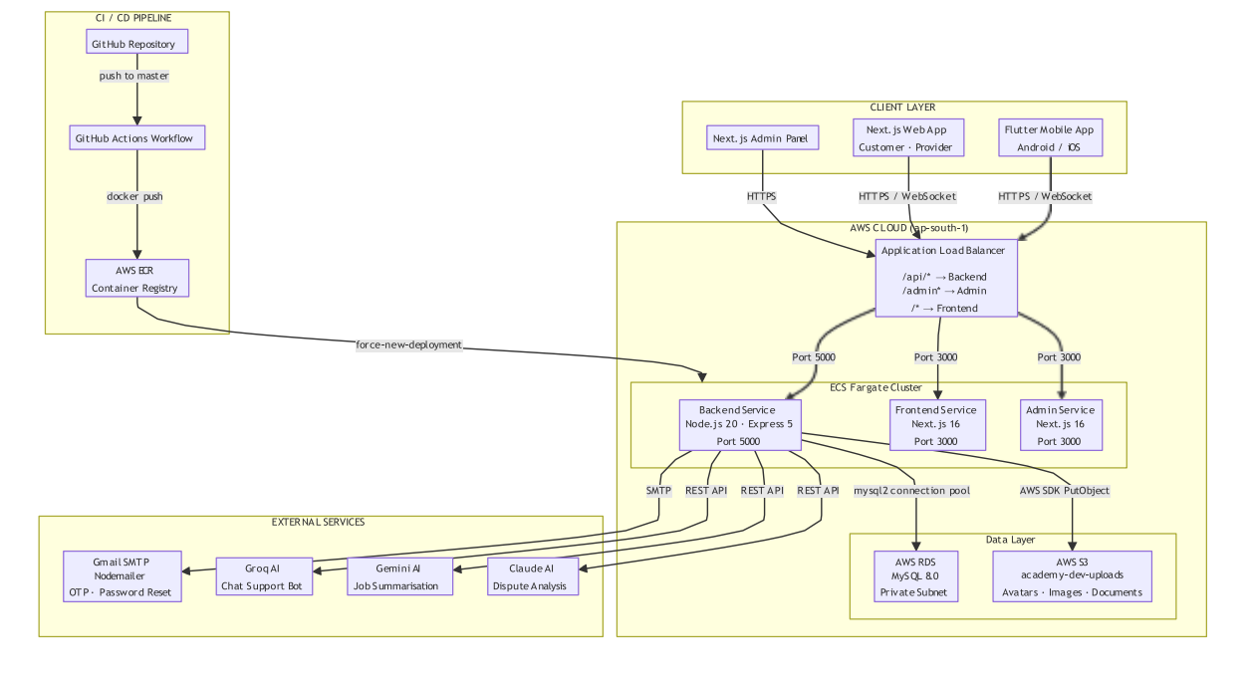

Figure 3.1 — Kaarkun System Architecture Diagram
3.3 Functional Requirements
Table 3.1 documents the twenty primary functional requirements defined for the Kaarkun system. Requirements are coded H (High priority) or M (Medium priority).
Table 3.1 — Kaarkun Functional Requirements
ID | Module | Requirement Description | Priority
FR-01 | Authentication | System shall allow customers/providers to register with name, email, phone, password, and role. | H
FR-02 | Authentication | System shall authenticate users with email and password, returning a signed JWT valid for 24 hours. | H
FR-03 | Authentication | Service providers shall submit identity documents for admin review before appearing publicly. | H
FR-04 | Job Management | Customers shall post a job request specifying title, description, category, date, and GPS location. | H
FR-05 | Job Management | System shall display open jobs to providers filtered by category and sorted by proximity. | H
FR-06 | Job Management | Customers shall view the status of all posted jobs: open, booked, completed, or cancelled. | M
FR-07 | Bidding | Service providers shall submit a bid specifying a quoted price and explanatory message. | H
FR-08 | Bidding | Customers shall view all bids and accept exactly one, transitioning the job to booked status. | H
FR-09 | Booking | Upon bid acceptance, system shall auto-generate a unique QR code delivered to the customer. | H
FR-10 | Booking | Provider shall scan the customer QR code on arrival (check-in) and again on completion (check-out). | H
FR-11 | Booking | System shall record timestamped check-in and check-out events visible to both parties. | M
FR-12 | Communication | System shall provide real-time in-app messaging via Socket.io between customer and provider. | H
FR-13 | Communication | Mobile app shall provide a rule-based AI chatbot accessible from the home screen. | M
FR-14 | GPS Tracking | Customer shall view provider real-time GPS location on a map after booking confirmation. | H
FR-15 | GPS Tracking | Provider app shall broadcast GPS coordinates via Socket.io at configurable intervals. | H
FR-16 | Reviews | After service completion, customer shall submit a star rating (1-5) and optional review. | H
FR-17 | Reviews | Provider public profile shall display average rating and five most recent written reviews. | M
FR-18 | Notifications | System shall create in-app notifications for: new bid, bid accepted, booking confirmed, service started, completed. | H
FR-19 | Admin | Admin panel shall allow administrators to view, search, activate, or deactivate any user account. | H
FR-20 | Admin | Admin panel shall display a dashboard of platform totals: users, providers, bookings, and open reports. | M
3.4 Use Case Analysis
Figure 3.3 and Figure 3.4 document the primary interactions of the Customer and Service Provider actors with the Kaarkun system respectively. The Administrator actor interacts exclusively through the Next.js admin panel to manage user accounts, approve provider credentials, monitor platform activity, and resolve reports.

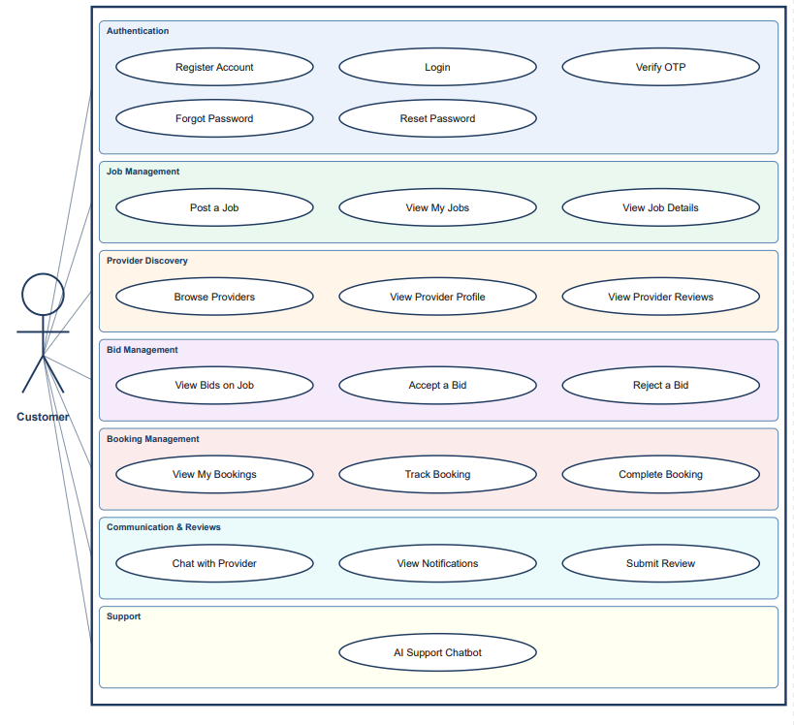

Figure 3.3 — Use Case Diagram: Customer Actor

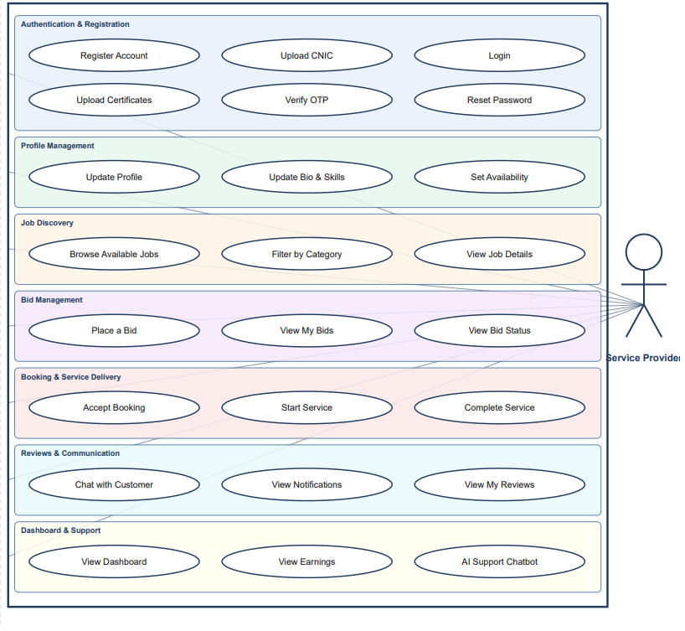

Figure 3.4 — Use Case Diagram: Service Provider Actor
3.5 Database Design (ERD Diagram)
The Kaarkun database is implemented in MySQL 8.0 and comprises eleven relational tables in Third Normal Form (3NF) to eliminate redundancy and enforce referential integrity through foreign key constraints. The central entity is users, which stores both customer and service provider accounts distinguished by a role column. The provider_profiles table extends the users record for provider-specific attributes. Jobs may receive multiple bids; one accepted bid creates a bookings record containing the auto-generated QR code string and check-in/checkout timestamps. Post-completion reviews are linked to bookings. Real-time messages are persisted for chat history. The notifications table supports platform governance. Figure 3.2 presents the complete Entity-Relationship Diagram.

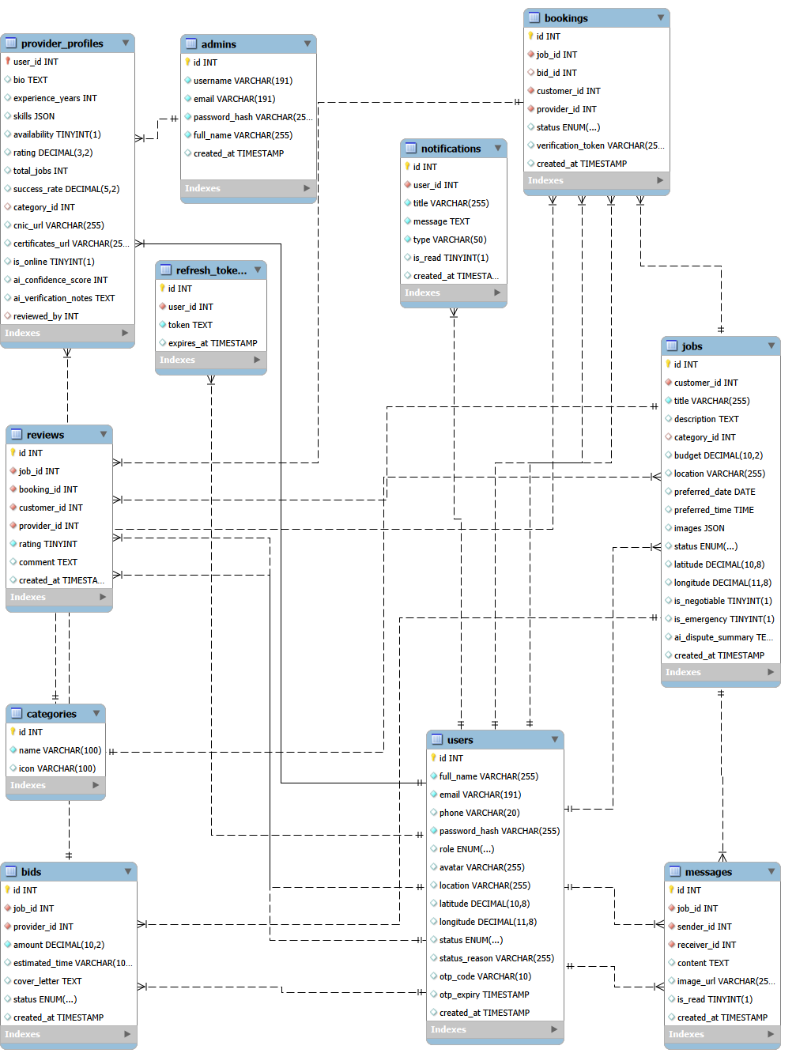

Figure 3.2 — Entity-Relationship Diagram: Kaarkun Database (11 Tables)

3.6 Implementation Features
3.6.1 Authentication and Authorization
User registration is processed by a POST /api/auth/register endpoint that validates inputs, hashes passwords using bcrypt (salt factor 10), and creates the user record. Login via POST /api/auth/login verifies the password hash and returns a signed JWT encoded with the user's ID, role, and email, set to expire after 24 hours. All protected API routes validate the JWT through Express middleware. Service provider registration additionally requires document upload pending administrator approval. Only verified providers appear in the public job feed.
3.6.2 Job Posting, Bidding, and Booking
Customers create job requests specifying title, description, category ID, preferred date, and GPS coordinates captured through the Flutter geolocator package. Verified providers retrieve open jobs through GET /api/jobs, filtered by category and proximity. Providers submit bids via POST /api/bids. Customers accept one bid via PATCH /api/bids/:id/accept, which atomically marks the bid as accepted, rejects remaining bids, updates the job status to booked, and triggers QR code generation.
3.6.3 QR Code Verification
On bid acceptance, the server generates a unique booking token via Node.js crypto.randomUUID() and encodes it as a QR image using the qrcode npm package. On arrival, the provider scans the customer's QR code and sends the decoded token to POST /api/bookings/:id/checkin, which validates the token and records a timestamped check-in event. An identical scan at completion triggers POST /api/bookings/:id/checkout, recording the checkout timestamp, transitioning the booking to completed, and unlocking the customer's review submission interface.
3.6.4 Real-Time Messaging and GPS Tracking
In-app chat uses Socket.io rooms keyed by booking ID. Both parties join the room on booking confirmation; emitted messages are persisted to the messages table and broadcast to the other party. GPS tracking is activated upon check-in: the provider Flutter app emits location_update Socket.io events every fifteen seconds; the server relays each event exclusively to the associated customer, whose Flutter screen updates a Google Maps marker in real time.
3.6.5 AI Chatbot
The Kaarkun chatbot is implemented as an on-device, rule-based keyword-matching engine within the Flutter application. An intent library maps normalised user input to predefined response categories covering common platform queries. The highest-confidence keyword match returns a scripted response; unmatched input triggers a graceful fallback. No network connection is required; responses are instantaneous.
3.6.6 Administration Panel
The Next.js admin panel provides authenticated administrator access to four management modules: User Management, Document Verification (review provider uploads, approve or reject credentials), Booking Monitor, and Dashboard (real-time platform totals). All admin API routes require a JWT with role = admin validated by dedicated server middleware.

3.6.7 Wallet and Transaction System
Kaarkun integrates a platform-managed digital wallet that enables customers to maintain a pre-funded balance for paying service providers and allows providers to receive earnings automatically upon booking completion. The wallet system is implemented across both the Flutter mobile application and the Next.js web frontend, supported by a dedicated set of REST API endpoints on the Node.js backend.
The wallet data model tracks two distinct balances for each user: the available balance, representing funds that are freely withdrawable, and the escrow balance, representing funds temporarily locked against an active booking. When a customer accepts a provider's bid, the agreed amount is moved into escrow. On booking completion, the escrow balance is released to the provider's available balance, creating a tamper-evident payment trail that is linked to the same booking record used by the QR attendance mechanism.
The following wallet operations are available through the platform.
— Customer top-up: Customers may add funds to their wallet in amounts between PKR 100 and PKR 50,000 per transaction. The top-up modal presents four quick-select presets (PKR 500, 1,000, 2,000, 5,000) alongside a free-entry amount field. The operation calls POST /api/wallet/topup and returns the updated balance.
— Withdrawal: Both customers and providers may withdraw available-balance funds via three payment methods: Bank Transfer, JazzCash, and EasyPaisa. A minimum withdrawal of PKR 500 is enforced server-side. The operation calls POST /api/wallet/withdraw with the requested amount and chosen method, and returns the new balance. Withdrawal requests are submitted to the respective payment channel; final settlement occurs according to the channel's processing timeline.
— Provider earnings: Service provider wallets are credited automatically when a booking transitions to completed status. Providers do not deposit funds; they only withdraw accumulated earnings. Accordingly, the top-up control is conditionally hidden in the provider-facing wallet interface, preventing an inapplicable workflow from appearing.
— Transaction history: All wallet events — top-ups, withdrawals, payments, refunds, and earnings — are persisted as timestamped transaction records classified by type (credit or debit) and sub-type (topup, withdrawal, payment, refund, earning). The transaction list is paginated (10 records per page) and is retrievable via GET /api/wallet/transactions?limit=10&offset=N. Each record stores the balance after the transaction, enabling a complete audit trail.
The wallet UI presents the available balance and escrow balance prominently on a gradient balance card. An information strip displaying the escrow amount appears conditionally only when funds are actively locked, avoiding unnecessary visual noise during periods with no active bookings. Toast notifications confirm successful operations and surface error messages without navigating away from the wallet screen.

3.6.8 Multilingual and Multi-Currency Interface
To address the multilingual character of the Kaarkun target market in Khyber Pakhtunkhwa — where users may prefer either English or Urdu as their primary language — the Flutter mobile application implements a complete internationalisation (i18n) framework using a custom LanguageProvider built on the Flutter ChangeNotifier pattern.
All user-visible strings in the Flutter application are managed through a centralised translation map defined in core/l10n/translations.dart. Two complete translation maps are maintained: enTranslations for English and urTranslations for Urdu. Each map is structured as a nested Dart Map using dot-notation keys (for example, 'wallet.topUpTitle', 'auth.login.title'). The LanguageProvider.t(key) method resolves a dot-separated path through the active translation map and returns the corresponding string, or falls back to the key itself if the path is not found, preventing null reference errors from missing translations.
The user's language preference is persisted in device storage using the SharedPreferences package under the key kaarkun_lang. This ensures that the selected language is restored across app restarts without requiring the user to re-select it on each launch. The LanguageProvider is registered as a top-level ChangeNotifier provider, making the current language reactive across the entire widget tree. Language switching takes effect immediately on the currently displayed screen without requiring navigation or an app restart.
The platform also implements a multi-currency display system through a companion CurrencyProvider. All monetary values are stored in Pakistani Rupees (PKR) in the database. The CurrencyProvider converts PKR amounts to the user's selected display currency at query time using fixed exchange-rate constants. Six currencies are supported: PKR (₨), USD ($), AED (د.إ), SAR (﷼), EUR (€), and GBP (£). Conversion rates are defined as PKR units per foreign currency unit (for example, USD: 278.0, GBP: 352.0). Converted amounts are formatted with the currency code prefix (e.g. USD 18.01) for foreign currencies, or as whole PKR integers (e.g. ₨ 5,000) for the base currency.
The user's currency selection is persisted in SharedPreferences under the key selected_currency and restored on app start via CurrencyProvider.loadCurrency(). The Settings screen exposes both the language selector (English / Urdu dropdown) and the currency selector (six-currency dropdown) within the same preferences panel, allowing users to configure both in a single location. Changes to either setting propagate instantly to all screens through the ChangeNotifier listener pattern.
The web frontend implements a parallel language context through a useLanguage() React hook that exposes a t(key) translation function, ensuring that the customer and provider web interfaces display localised text consistently with the mobile application.
3.7 Project Screenshots
The following figures present screenshots of the deployed Kaarkun mobile application and administration panel, illustrating the implemented user interface across the key user flows.

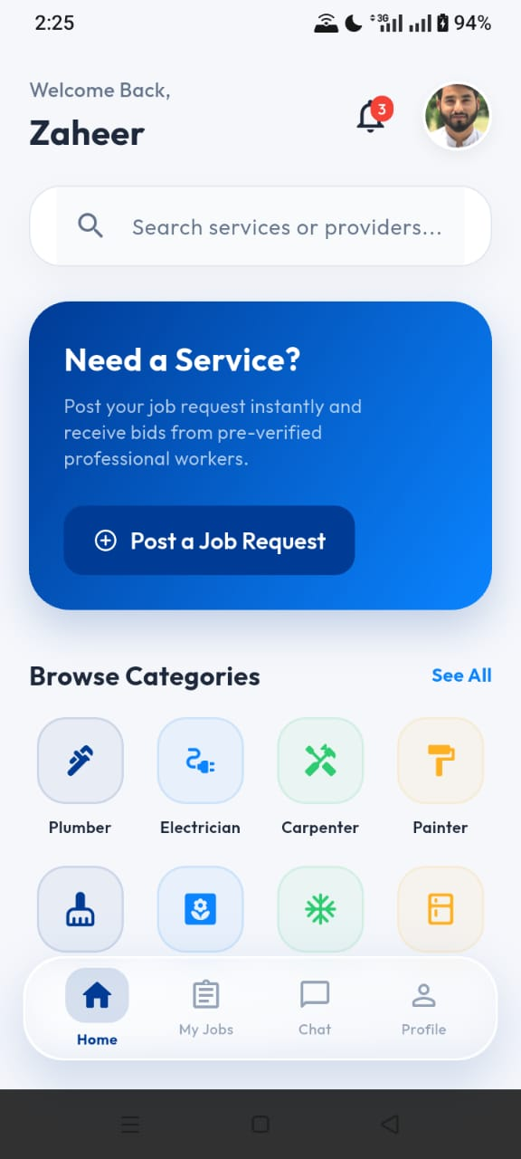
Image 3.1 — Kaarkun App: Customer Home Screen

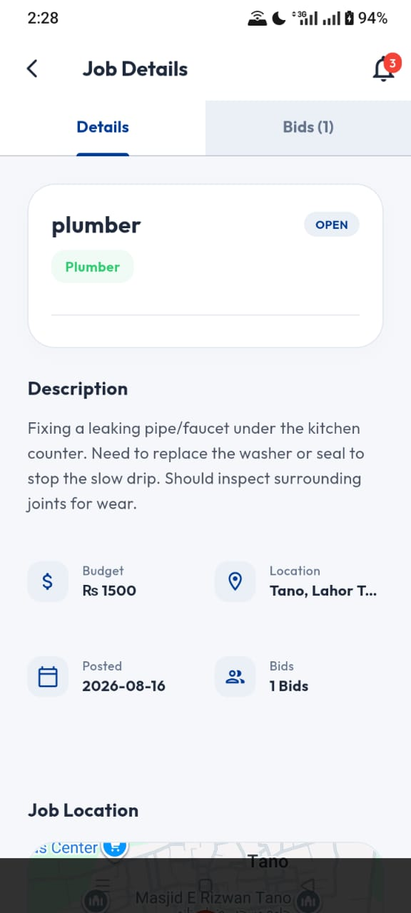
Image 3.2 — Kaarkun App: Post a Job Screen

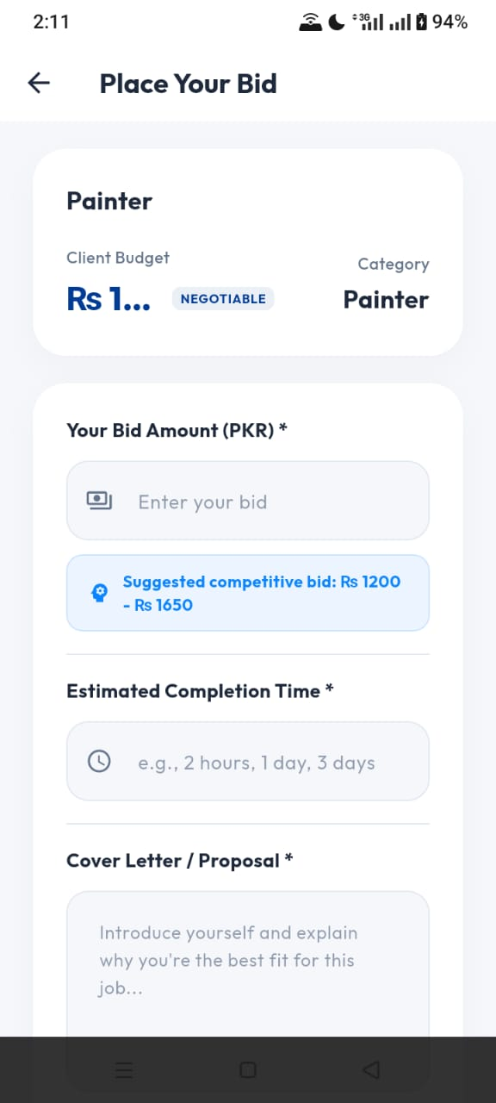
Image 3.3 —Kaarkun App: Provider Bid Screen

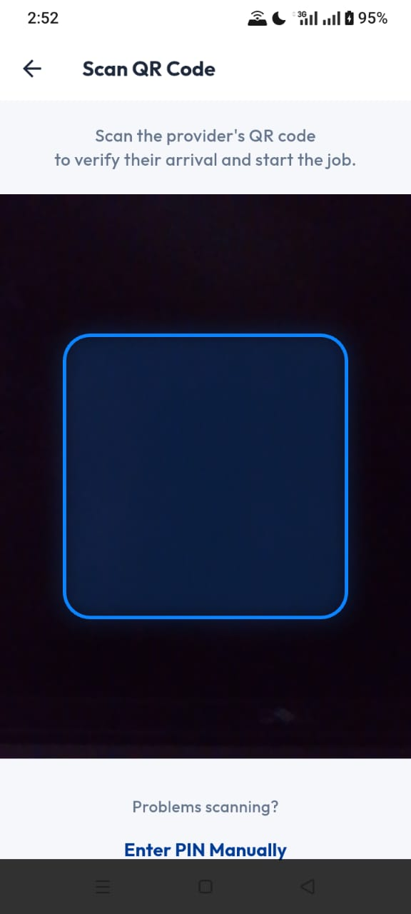
Image 3.4 — Kaarkun App: QR Code Verificatoin Screen

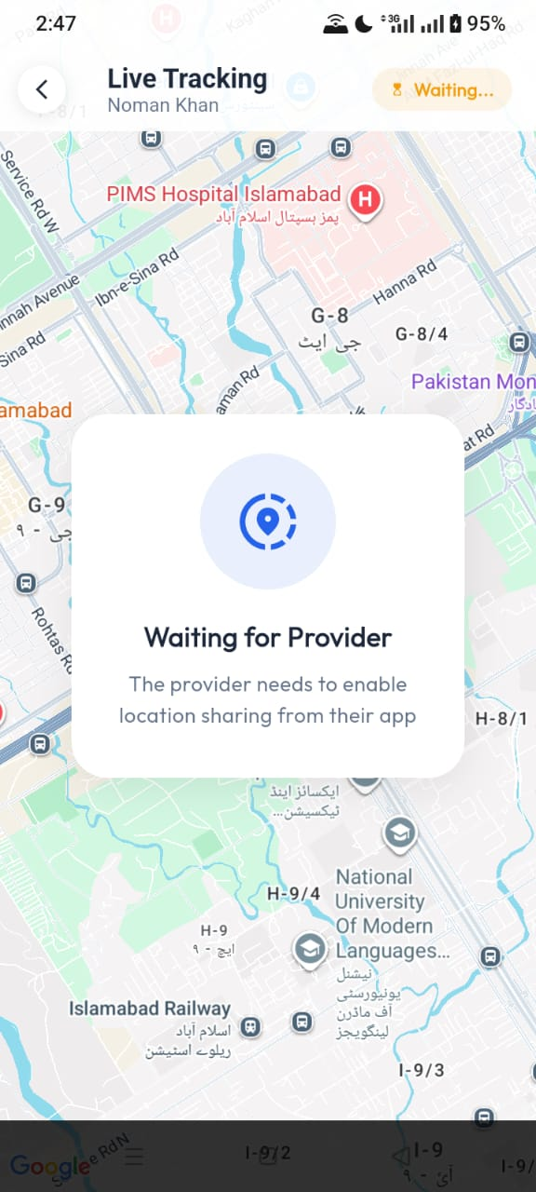
Image 3.5 — Kaarkun App: Real-Time GPS Tracking Screen

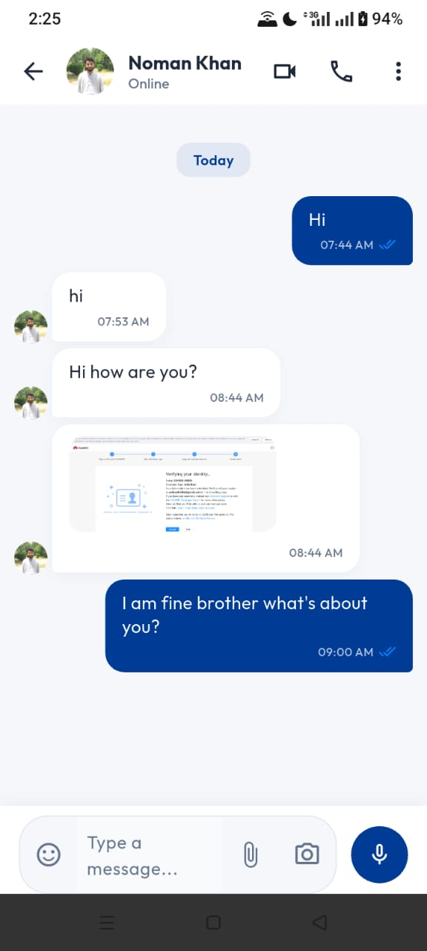
Image 3.6 — Kaarkun App : In-App Chat Screen
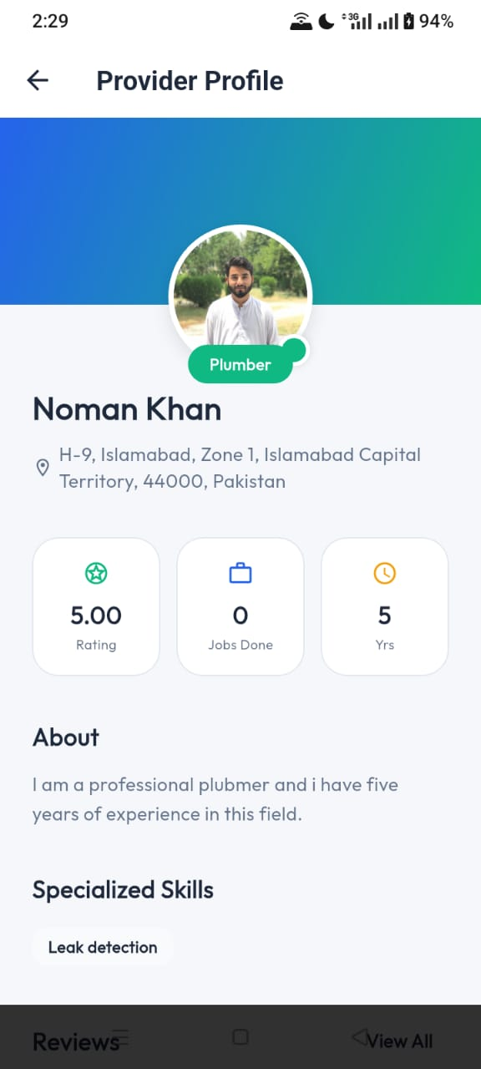
Image 3.7 — Kaarkun App : Provider Profile Screen

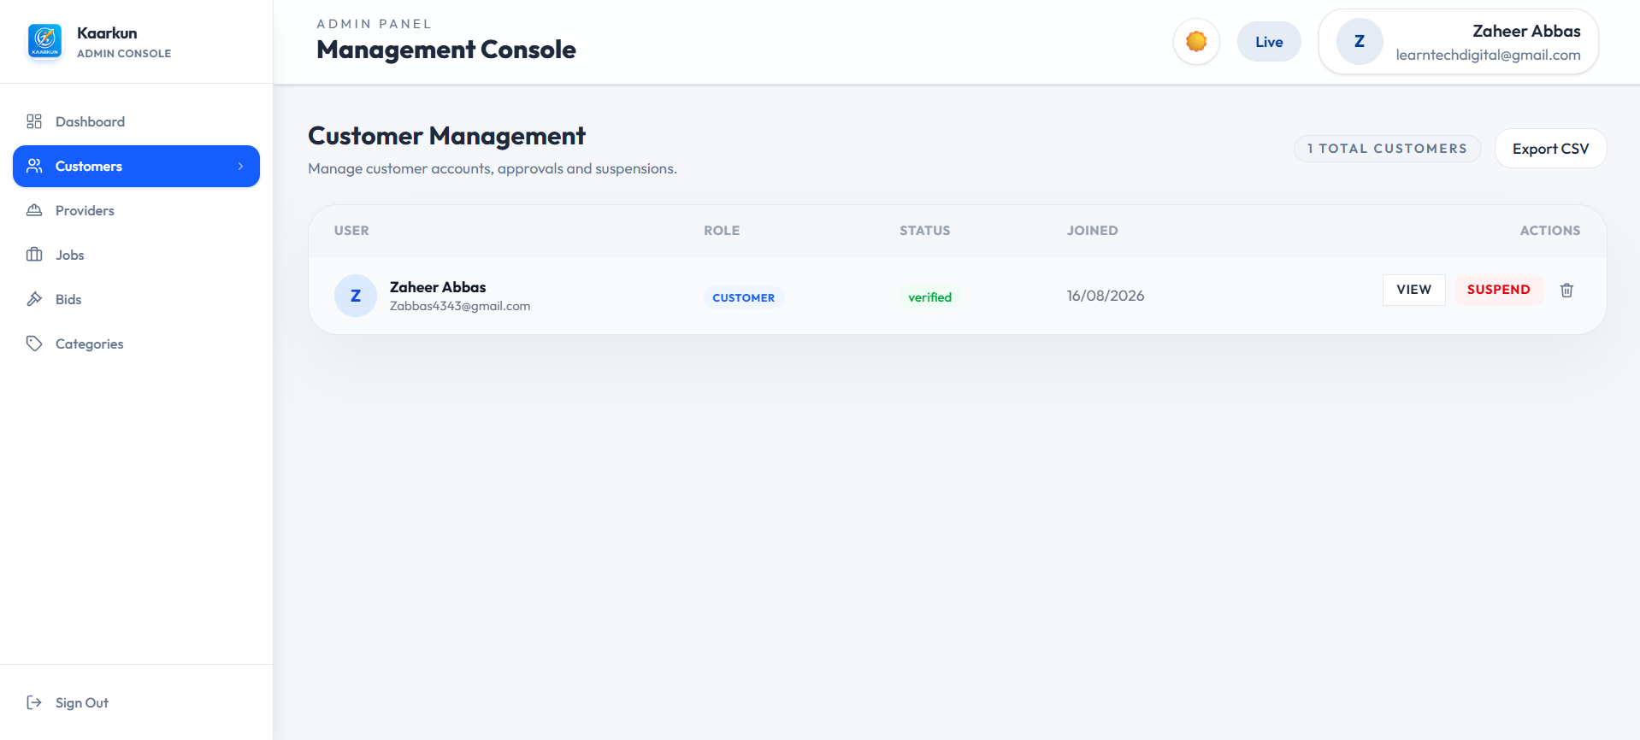

Image 3.8 — Kaarkun Admin Panel : User Management

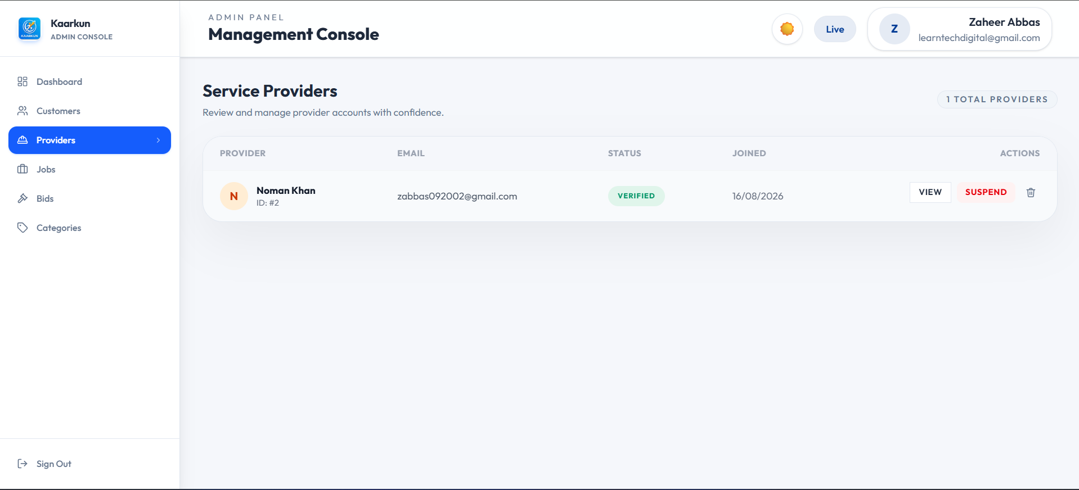

Image 3.9 — Kaarkun Admin Panel : Provider Verification
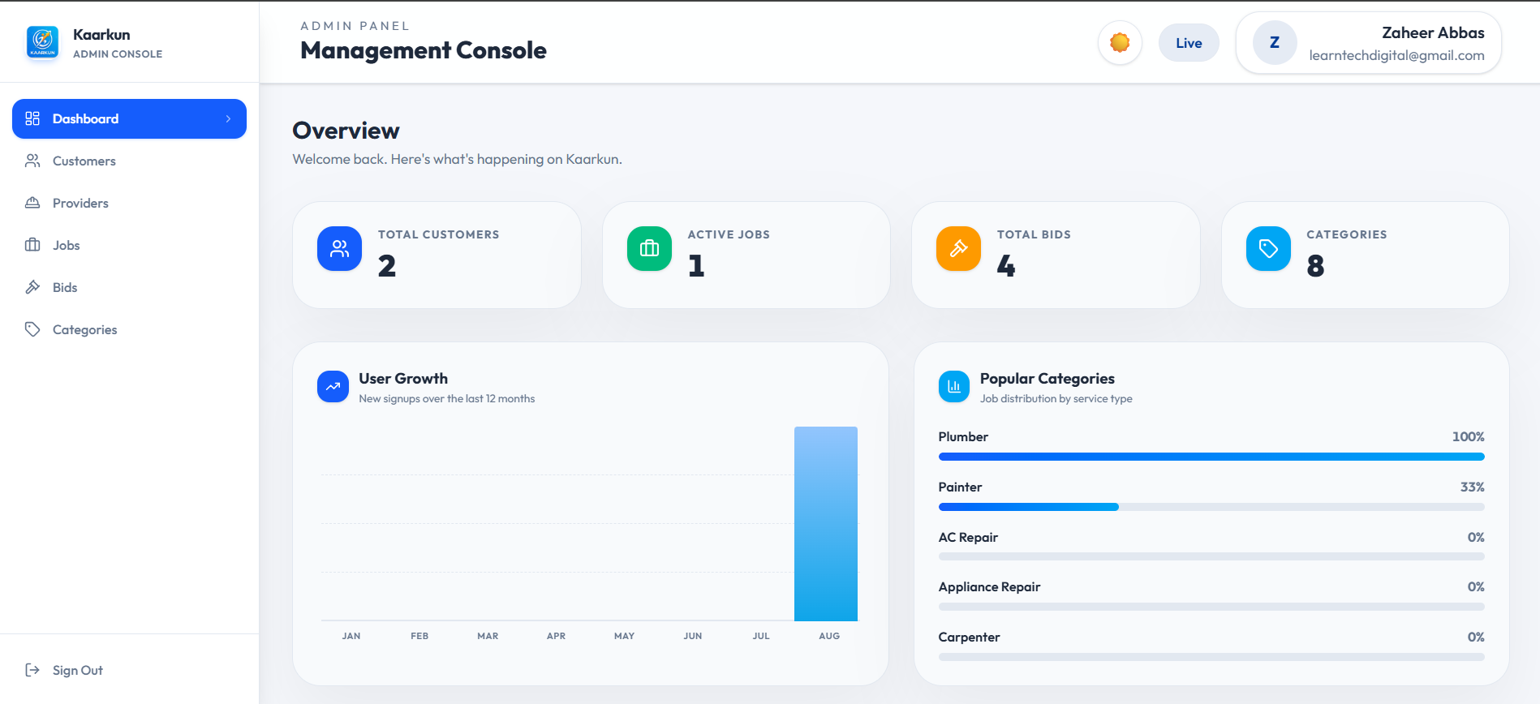

Image 3.10 — Kaarkun Admin Panel : Dashboard Overview

3.8 Security Design
Table 3.2 summarises the security measures implemented across the system layers.
Table 3.2 — Security Measures by System Layer
Layer | Measure | Technology
Authentication | Stateless JWT access control; 24-hour token expiry | jsonwebtoken
Password storage | bcrypt one-way hash with salt factor 10; no plaintext storage | bcrypt
Database queries | Parameterised prepared statements; prevents SQL injection | mysql2
API access control | CORS policy restricts accepted origins to registered clients | cors (npm)
Input validation | Flutter form validators (client) + express-validator (server) | express-validator
File uploads | MIME-type check and size limit enforced on document uploads | multer

3.9 Deployment Architecture and DevOps Pipeline
The Kaarkun platform is deployed to Amazon Web Services (AWS) in the ap-south-1 (Mumbai) region, bringing the system into a production-grade cloud environment. All infrastructure resources are defined as code using Terraform, and deployment is fully automated through a GitHub Actions CI/CD pipeline. This section documents the deployment architecture, container strategy, cloud infrastructure, and secret management approach.
3.9.1 Continuous Integration and Delivery (CI/CD)
A GitHub Actions workflow defined in .github/workflows/deploy-aws.yml triggers automatically on every push to the master branch. The workflow performs the following steps in sequence.
1. Repository checkout using actions/checkout@v4.
2. AWS credential configuration from GitHub repository secrets (AWS_ACCESS_KEY_ID and AWS_SECRET_ACCESS_KEY) using aws-actions/configure-aws-credentials@v4.
3. Authenticated login to Amazon Elastic Container Registry (ECR) using aws-actions/amazon-ecr-login@v2, enabling Docker push access.
4. Docker image build and push for each of the three applications: the Node.js backend (from ./backend), the Next.js customer web frontend (from ./web/kaarkun), and the Next.js admin panel (from ./admin). Frontend and admin images receive the NEXT_PUBLIC_API_URL and NEXT_PUBLIC_WS_URL build arguments so that the compiled JavaScript bundles point to the correct ALB endpoint at build time.
5. ECS service update via aws ecs update-service --force-new-deployment for each of the three ECS services, instructing ECS to pull the newly pushed image and restart running tasks with zero-downtime rolling replacement.
This pipeline eliminates manual deployment steps, ensures that the live environment always reflects the master branch, and produces a deterministic, repeatable deployment process.
3.9.2 Docker Container Architecture
Each application is packaged as an independent Docker image using multi-stage build patterns to minimise image size and attack surface. All images use node:20-alpine as the base image and execute as a non-root USER node for security hardening.
— Backend container (backend/Dockerfile): Two-stage build. The deps stage installs production Node.js dependencies; the final stage copies dependencies and source code. The container exposes port 5000 and starts with node app.js.
— Frontend container (web/kaarkun/Dockerfile): Two-stage build. The build stage installs all dependencies and compiles the Next.js application; the runner stage copies only the production output and node_modules. Exposes port 3000 and starts with npm start.
— Admin panel container (admin/Dockerfile): Three-stage build with a dedicated deps stage, a build stage that compiles the Next.js admin application, and a runner stage. Exposes port 3000 and starts with node server.js.
For local development, a docker-compose.yml file connects all four services (MySQL database, backend, frontend, admin) through a shared Docker network. The database service includes a health check so that the backend container waits for MySQL to be fully initialised before accepting connections.
3.9.3 AWS Cloud Infrastructure
The following AWS services form the production infrastructure for the Kaarkun platform.
— Amazon Elastic Container Registry (ECR): Three private repositories store the versioned Docker images for backend, frontend, and admin respectively.
— Amazon Elastic Container Service (ECS) with Fargate: Serverless container orchestration. One ECS cluster (academy-dev-cluster) hosts three ECS services: academy-dev-backend, academy-dev-frontend, and academy-dev-admin. Each service runs a Fargate task definition with 512 CPU units and 1,024 MB of memory. Tasks run in private subnets and do not hold public IP addresses, limiting the attack surface.
— Application Load Balancer (ALB): The single public entry point for all HTTP traffic. The ALB listens on port 80 and applies path-based routing rules: requests matching /api/* are forwarded to the backend service, requests matching /admin or /admin/* are forwarded to the admin panel service, and all other requests are forwarded to the frontend service.
— Amazon RDS (MySQL 8.0): A managed relational database instance running in private subnets. The database is not internet-accessible; only ECS tasks within the same VPC security group can connect on the MySQL port (3306).
— Amazon CloudWatch Logs: All ECS container output is streamed to CloudWatch log groups, enabling centralised log inspection and monitoring without SSH access to containers.
— AWS Identity and Access Management (IAM): An ECS task execution role grants the minimum permissions required for containers to pull images from ECR and write logs to CloudWatch.
3.9.4 Network Architecture and Security Groups
The VPC is divided into two public subnets and two private subnets across two Availability Zones. Public subnets host the NAT Gateway, which enables outbound internet access for private resources without exposing them inbound. The Internet Gateway serves the public subnets. ECS task containers and the RDS database instance run in private subnets with no public IP addresses.
Three security groups enforce the principle of least privilege. The ALB security group accepts inbound HTTP traffic from any source (0.0.0.0/0). The ECS security group accepts traffic only from the ALB security group. The RDS security group accepts MySQL traffic only from the ECS security group. This layered boundary prevents direct internet access to the application containers or the database.

3.9.5 Infrastructure as Code (Terraform)
All AWS resources described above are defined declaratively using HashiCorp Terraform in the terraform/ directory. The provider.tf file sets the AWS provider region from a variable; variables.tf declares all configurable parameters including aws_region, project_name, environment, vpc_cidr, and container ports; and outputs.tf exposes post-apply values including the ALB DNS name, ECR repository URLs, and the RDS endpoint. The database password is generated at apply time using a random_password resource and is marked sensitive in Terraform outputs, ensuring it is never stored as plaintext in version-controlled files. Infrastructure is provisioned by running:
terraform apply -var-file=terraform.tfvars -var-file=secrets.tfvars -auto-approve
The secrets.tfvars file, which contains sensitive credential values, is excluded from version control via .gitignore. A secrets.tfvars.example template documents the required variables without exposing values.
3.9.6 Secret Management
Deployment secrets are managed at two levels. GitHub repository secrets (AWS_ACCESS_KEY_ID and AWS_SECRET_ACCESS_KEY) are injected as environment variables into the GitHub Actions runner by the workflow, enabling AWS API authentication without hardcoding credentials in the workflow file. Application runtime secrets (EMAIL_USER, EMAIL_PASS, JWT_SECRET, DB_PASSWORD) are injected into ECS containers as environment variables via the Terraform-managed task definition. Local development secrets are stored in backend/.env, which is excluded from version control.
3.9.7 Deployment Flow Summary
The complete deployment sequence, from source code commit to live user-accessible application, proceeds through the following seven steps.
1. A developer pushes code to the master branch of the GitHub repository.
2. GitHub Actions automatically triggers the deployment workflow.
3. The workflow authenticates to AWS using the configured GitHub Secrets.
4. Docker images for the backend, frontend, and admin panel are built locally within the GitHub Actions runner.
5. The three images are pushed to their respective ECR repositories, tagged as the latest version.
6. Each ECS service is updated to force a new deployment, causing ECS to pull the latest image and replace running task instances in a rolling fashion.
7. The ALB continues to route public traffic to available task instances throughout the rolling update, ensuring zero downtime for active users.

Following the initial implementation and functional testing phases, a series of targeted user interface refinements were applied across the administration panel, Flutter mobile application, and Next.js web frontend. These refinements address usability, visual consistency, and role-appropriate feature exposure without altering any underlying business logic or API contracts.
3.10 User Interface Design Refinements
3.10.1 Administration Panel Enhancements
The administration panel dashboard received the following enhancements to improve information clarity and visual consistency.
— Dashboard analytics chart: A User Growth bar chart was implemented that displays new user registrations for each month from January through the current calendar month. Each bar is positioned using absolute bottom-anchored CSS within a relative-height container, resolving a rendering defect where percentage-height children of flex containers collapsed to zero. Hovering over a bar reveals a tooltip with the exact signup count.
— Statistic card icon visibility: The four dashboard statistic cards (Total Customers, Active Jobs, Total Bids, Categories) were updated to use solid-colour icon backgrounds (blue-600, emerald-500, amber-500, and sky-500) with white icons. This replaced a light-background design that produced insufficient contrast in light mode.
— Sidebar brand icon: The placeholder icon in the administration panel sidebar was replaced with the actual Kaarkun application icon (icon.png). A plain HTML img element is used rather than the Next.js Image component, since the Next.js image optimisation endpoint (/_next/image) is not routed through the ALB configuration for the admin panel.
— Card hover border: The card hover border colour was changed from the dark primary navy (#003B95) to a subtle blue-200 (#BFDBFE) in light mode and a semi-transparent blue-500 in dark mode, reducing visual harshness on hover interactions.
— Content layout alignment: The main content area left padding was corrected from 288 px (pl-72) to 256 px (pl-64) to exactly match the fixed sidebar width, eliminating a visible background gap strip.
3.10.2 Flutter Mobile Application Refinements
Four refinements were applied to the Flutter mobile application.
— Wallet balance integer display: Currency amounts on the Wallet screen were changed from two-decimal fixed-point formatting (PKR 5,000.00) to whole-number formatting (PKR 5,000). The _fmt helper method was updated to use Dart's num.round().toString() in place of toStringAsFixed(2), consistent with the PKR-denominated context where sub-rupee precision has no practical meaning.
— Role-based wallet top-up visibility: The wallet top-up button is now hidden for service provider accounts. Providers receive earnings automatically when a booking is completed and have no requirement to deposit funds; displaying a top-up control for providers introduced a confusing and inapplicable workflow. An AuthService role check (role == 'provider') conditionally removes the top-up button and its associated spacing from the balance card.
— Browse Jobs filter modal dialogs: The Category and Sort By selection controls on the Browse Jobs screen were converted from slide-up bottom sheets (showModalBottomSheet) to centred modal dialog boxes (showDialog with a custom Dialog widget). The redesigned dialogs display a scrollable list of options with icon badges per category and a checkmark indicator on the currently selected item, improving discoverability on larger-screen devices.
— Settings screen simplification: The Payment Methods settings entry was removed from the Settings screen. As the platform currently does not integrate a third-party payment gateway, the entry was a placeholder that led to an incomplete workflow; its removal reduces cognitive load for users navigating the settings menu.
3.10.3 Web Frontend Navigation Refinements
Two navigation refinements were applied to the Next.js customer and provider web frontend.
— Authentication page isolation: The Forgot Password page (/forgot-password) was added to the PUBLIC_ROUTES list in the AppShell component. Pages on the public routes list render without the authenticated sidebar and navigation bar, presenting only the page content to unauthenticated users. Previously, the Forgot Password page inadvertently received the authenticated navigation shell because it was absent from the public route list, producing a disorienting interface for users who were not logged in.
— Landing page brand icon: The placeholder Sparkles icon in the public-facing landing page navigation bar (LandingNavbar component) was replaced with the actual Kaarkun application icon (icon.png), rendered using a plain img element for compatibility with the ALB routing configuration. This update aligns the public landing page branding with the administration panel and mobile application.

CHAPTER-IV
RESULTS AND DISCUSSION
4.1 Testing Approach
System evaluation was conducted in two phases. The first phase comprised functional black-box testing of all twenty functional requirements. Each requirement was formulated as one or more discrete test cases executed by a simulated user operating the Flutter mobile application or Next.js web application against a locally running Node.js/Express.js server. Test outcomes were recorded as Pass or Fail based on whether the system response exactly matched the expected output. The second phase comprised integration testing of five critical cross-module workflows. All tests were performed on a Windows 11 development machine with MySQL 8.0 and Node.js v18 running locally. The Flutter app was tested on Android Emulator API level 33 and on a physical Android device.
4.2 Functional Testing Results
Table 4.1 presents the complete functional test case results. All twenty functional requirements were verified through a total of twenty-five test cases. The overall pass rate was 25/25 (100%), indicating that all defined functional requirements were satisfied by the implemented system.
Table 4.1 — Functional Test Case Results
TC-ID | FR | Test Case Description | Expected Result | Actual | Status
TC-01 | FR-01 | Register new customer with valid inputs | User created; success response returned | As expected | PASS
TC-02 | FR-01 | Attempt registration with duplicate email | HTTP 409 conflict error returned | As expected | PASS
TC-03 | FR-02 | Login with correct credentials | JWT token returned in response body | As expected | PASS
TC-04 | FR-02 | Login with wrong password | HTTP 401 unauthorised error | As expected | PASS
TC-05 | FR-03 | Provider uploads identity documents | Files saved; account set to pending | As expected | PASS
TC-06 | FR-04 | Customer posts a job with all required fields | Job created with status = open | As expected | PASS
TC-07 | FR-05 | Verified provider views open job list | Jobs returned, sorted by proximity | As expected | PASS
TC-08 | FR-06 | Customer views own posted jobs | All jobs with correct statuses returned | As expected | PASS
TC-09 | FR-07 | Provider submits bid on an open job | Bid record created with status = pending | As expected | PASS
TC-10 | FR-07 | Provider submits second bid on same job | HTTP 409 duplicate bid rejected | As expected | PASS
TC-11 | FR-08 | Customer accepts one bid | Bid accepted; job booked; others rejected | As expected | PASS
TC-12 | FR-09 | QR code generated on bid acceptance | Booking record contains non-null qr_code | As expected | PASS
TC-13 | FR-10 | Provider scans QR on arrival | Checkin_at timestamp recorded; in-progress | As expected | PASS
TC-14 | FR-11 | Provider scans QR on completion | Checkout_at recorded; status = completed | As expected | PASS
TC-15 | FR-12 | Customer sends message to provider | Message persisted; received via Socket.io | As expected | PASS
TC-16 | FR-13 | User types "how to post a job" in chatbot | Scripted response returned within 100 ms | As expected | PASS
TC-17 | FR-14 | Customer opens tracking screen during booking | Google Maps shows provider marker | As expected | PASS
TC-18 | FR-15 | Provider app emits GPS location event | Customer map marker moves to new location | As expected | PASS
TC-19 | FR-16 | Customer submits 4-star review after completion | Review saved; provider avg_rating updated | As expected | PASS
TC-20 | FR-17 | View provider public profile | Shows avg rating and 5 most-recent reviews | As expected | PASS
TC-21 | FR-18 | Check notification on bid acceptance | Provider notification created, correct type | As expected | PASS
TC-22 | FR-18 | Customer receives notification on booking confirmed | Customer notification created, correct type | As expected | PASS
TC-23 | FR-19 | Admin deactivates a user account | is_active set to false; login blocked | As expected | PASS
TC-24 | FR-19 | Admin approves provider credentials | is_verified = true; provider visible in feed | As expected | PASS
TC-25 | FR-20 | Admin views dashboard statistics | Platform totals correctly returned | As expected | PASS
4.3 Integration Testing Results
Table 4.2 presents the five integration test scenarios. All integration tests passed.
Table 4.2 — Integration Test Scenarios
IT-ID | Scenario | Modules Involved | Status
IT-01 | Complete booking lifecycle: job post -> bid -> accept -> QR check-in -> checkout -> review | Job Mgmt, Bidding, Booking, QR Engine, Reviews, Notifications | PASS
IT-02 | Real-time tracking: provider emits GPS -> server relays -> customer map updates | GPS Module, Socket.io Server, Flutter Maps | PASS
IT-03 | Full chat exchange: customer sends message -> persisted -> provider receives -> replies | Chat Module, Socket.io, Messages Table | PASS
IT-04 | Admin approves provider -> provider logs in -> appears in customer job feed | Admin Panel, Auth Module, Job Feed | PASS
IT-05 | Chatbot: user queries -> keyword match -> response -> unmatched query fallback | AI Chatbot (Client-side) | PASS
4.4 Requirements Compliance Matrix
Table 4.3 maps each research objective to the system features addressing it and the test cases that verified those features. All five objectives were fully met.
Table 4.3 — Research Objectives Compliance Matrix
Obj. | Research Objective | Addressing Feature(s) | Verified By | Status
O1 | Design and implement a multi-platform marketplace | Flutter app, Next.js web app, REST API, MySQL database | TC-01 to TC-25 | MET
O2 | Implement transparent competitive bidding | Job posting, bid submission, bid acceptance with auto-rejection | TC-06 to TC-11 | MET
O3 | Provide real-time communication and GPS tracking | Socket.io chat, GPS location events, Google Maps tracking | TC-15, TC-17, TC-18, IT-02, IT-03 | MET
O4 | Integrate AI assistant chatbot | Rule-based keyword-matching chatbot in Flutter app | TC-16, IT-05 | MET
O5 | Establish trust through verified identity, QR attendance, and peer reviews | Document verification, QR check-in/checkout, review system | TC-05, TC-12-14, TC-19, TC-20, TC-24 | MET
4.5 Discussion
The results confirm that the Kaarkun platform successfully addresses each of the five research objectives and that all twenty functional requirements defined during the design phase were correctly implemented and independently verified. The 100% pass rate across all functional and integration tests demonstrates internal consistency between the requirements, implementation, and verification phases.
The most operationally significant contribution identified through testing was the integration of QR code-based attendance verification. This mechanism directly eliminates the trust deficit problem identified in Section 1.2, creating a tamper-evident, timestamped audit trail for each booking without requiring third-party payment escrow. None of the South Asian platforms reviewed in Table 2.1 employ an equivalent QR-gated attendance mechanism, representing a genuine differentiation in the local context.
The competitive bidding system addresses the price opacity problem by allowing multiple verified providers to bid transparently on a customer-defined job specification. Real-time GPS tracking proved technically straightforward given the Socket.io architecture already deployed for chat, but its user experience significance is substantial, eliminating the uncertainty about provider arrival time that characterises existing informal arrangements.
The 100% pass rate reflects controlled testing by the developer in a local environment. Real-world deployment would introduce additional variables including network latency, concurrent user load, and mobile device heterogeneity. A production deployment would require load testing, penetration testing, and a beta pilot with real users. These limitations are acknowledged in Section 1.4 and addressed in the recommendations of Section 6.2.

CHAPTER-V
SUMMARY
This study addressed the problem of unorganised, informal domestic and skilled-trade service markets in Pakistan, specifically in the Khyber Pakhtunkhwa region. The existing system, characterised by word-of-mouth referrals, unverified workers, opaque pricing, and no formal mechanism for accountability, imposes high transaction costs on both customers seeking reliable service and skilled workers seeking consistent employment. No locally developed digital platform adequately addressed this problem at the time of this research.
The system was designed using the Design Science Research (DSR) methodology of Hevner et al. (2004), operationalised through the six-phase Peffers et al. (2007) process model and Agile two-week development sprints. Twenty functional requirements across seven modules were formally defined and used as the basis for both implementation and evaluation.
The technical architecture adopted a three-tier client-server model comprising three client applications — Flutter mobile app, Next.js customer web app, and Next.js admin panel — communicating with a unified Node.js/Express.js REST API and MySQL 8.0 database. Real-time capabilities were delivered via Socket.io WebSocket connections. The database was designed to Third Normal Form, comprising eleven relational tables with enforced foreign key integrity. External integrations included the Google Maps Platform, the qrcode npm package, and a client-side rule-based AI chatbot.
The platform's key functional contributions were as follows. First, a transparent bidding system allows multiple verified providers to compete on posted job requests. Second, a QR code verification mechanism creates a tamper-evident attendance record for each booking. Third, real-time GPS location tracking via Socket.io gives customers live visibility of their provider's location after booking confirmation. Fourth, Socket.io-powered in-app messaging enables direct customer-provider communication within the platform. Fifth, an on-device rule-based AI chatbot provides instant self-service platform guidance without network dependency. Sixth, a comprehensive administrative panel gives administrators full control over user management, credential verification, and dispute resolution.
System security was addressed through JWT-based stateless authentication with 24-hour token expiry, bcrypt password hashing with salt factor 10, parameterised SQL queries, CORS-restricted API access, file upload validation via multer, and server-side input validation using express-validator.
Evaluation was performed through systematic functional black-box testing of 25 test cases covering all 20 requirements, and through 5 integration test scenarios covering cross-module workflows. All 25 functional test cases and all 5 integration tests achieved a Pass result, yielding a 100% compliance rate. A requirements compliance matrix confirmed that all five research objectives were fully met by the implemented system. The QR attendance mechanism and the GPS tracking integration were identified as the two features with the greatest user experience significance not present in comparable regional platforms.

CHAPTER-VI
CONCLUSION AND RECOMMENDATIONS
6.1 Conclusion
This project set out to design, build, and evaluate a digital service marketplace that would address the structural inefficiencies of the informal skilled-trade and domestic-service sector in Khyber Pakhtunkhwa, Pakistan. The resulting system, Kaarkun, is a fully functional multi-platform application comprising a Flutter mobile app, a Next.js customer web application, a Next.js administration panel, a Node.js/Express.js REST API, and a MySQL relational database, unified by Socket.io real-time communication infrastructure.
The platform successfully implements all five design objectives established at the outset. The competitive bidding mechanism replaces opaque informal price negotiation with a transparent, customer-controlled selection process. The QR code check-in/checkout workflow creates an unforgeable, timestamped service attendance record that eliminates the primary source of booking disputes. Real-time GPS tracking and Socket.io in-app messaging together eliminate the information asymmetry and communication gaps that characterise existing informal arrangements. The administrator panel and document-verification workflow establish an institutional trust layer through identity screening of service providers. The on-device AI chatbot provides zero-latency self-service guidance.
System evaluation confirmed that all twenty functional requirements and all five research objectives were fully satisfied. A comparative analysis with Urban Company, TaskRabbit, and Rozgar.pk confirms that Kaarkun introduces capabilities — notably the QR attendance mechanism and the local regional focus — not present in comparable platforms available to Pakistani users. The project demonstrates that a production-quality multi-platform service marketplace can be architected and implemented by a single developer within an academic project timeframe using freely available open-source technologies.
6.2 Recommendations
On the basis of the limitations identified in Section 1.4 and the experience gained during development and evaluation, the following seven recommendations are made for future development of the Kaarkun platform:
1. Large Language Model Chatbot Integration. The current rule-based chatbot should be replaced or supplemented by an LLM API integration — for example, the Anthropic Claude API or Google Gemini API — to support open-ended conversational queries, multilingual input, and contextual service recommendation.
2. Integrated Payment Gateway. Integration with a local payment gateway such as JazzCash or EasyPaisa would allow secure in-app payments and automated fund disbursement to providers, closing the most significant remaining workflow gap.
3. Real User Study and Usability Evaluation. A formal usability study with representative users from the target demographic should be conducted to identify friction points and validate that the platform addresses the five structural problems from the end-user perspective.
4. Cloud Deployment and Load Testing. The system should be deployed to a cloud environment (AWS or Azure) and subjected to concurrent-user load testing to determine scalability limits before a public launch.
5. Push Notification Integration. Integration with Firebase Cloud Messaging (FCM) would allow push notifications to be delivered when the app is closed, which is critical for time-sensitive events such as bid acceptance and provider check-in alerts.
6. Multi-Language Support. Given that the target user base includes Pashto-speaking users, the application interfaces should be internationalised with full Pashto and Urdu language packs using Flutter's built-in internationalisation framework.
7. Rating-Based Provider Discovery Algorithm. A weighted scoring algorithm incorporating verified rating average, job completion rate, response time, and distance would improve match quality and incentivise high-quality service behaviour.

LITERATURE CITED
Ahmad, S., & Hussain, M. (2022). Digital labour platforms and informal sector employment in Pakistan: Opportunities and structural barriers. Pakistan Journal of Social Sciences, 42(1), 45-61.
Ahmed, N., Rehman, A., & Shah, S. A. (2021). Mobile commerce adoption in developing economies: Evidence from Khyber Pakhtunkhwa, Pakistan. Journal of Information Technology & Development, 27(3), 112-129.
Beck, K., Beedle, M., van Bennekum, A., Cockburn, A., Cunningham, W., Fowler, M., Grenning, J., Highsmith, J., Hunt, A., Jeffries, R., Kern, J., Marick, B., Martin, R. C., Mellor, S., Schwaber, K., Sutherland, J., & Thomas, D. (2001). Manifesto for agile software development. Agile Alliance.
Choudary, S. P. (2015). Platform scale: How an emerging business model helps startups build large empires with minimum investment. Platform Thinking Labs.
De Reuver, M., Sorensen, C., & Basole, R. C. (2018). The digital platform: A research agenda. Journal of Information Technology, 33(2), 124-135.
Evans, D. S., & Schmalensee, R. (2016). Matchmakers: The new economics of multisided platforms. Harvard Business Review Press.
Farhan, M., & Baig, U. (2020). An analysis of freelancing platforms and gig economy growth in Pakistan. Proceedings of the International Conference on Computing and Information Technology, 23-29.
Google LLC. (2024). Google Maps Platform documentation: Geocoding API.
Hagiu, A., & Wright, J. (2015). Multi-sided platforms. International Journal of Industrial Organization, 43, 162-174.
Hevner, A. R., March, S. T., Park, J., & Ram, S. (2004). Design science in information systems research. MIS Quarterly, 28(1), 75-105.
International Labour Organization (ILO). (2022). World employment and social outlook: The role of digital labour platforms in transforming the world of work. ILO.
Khan, Z., & Qureshi, J. A. (2021). Trust mechanisms in peer-to-peer service platforms: A review of design strategies. Telematics and Informatics, 58, 101530.
Lim, W. M., Kumar, S., & Ali, F. (2022). Advancing knowledge through literature reviews: What, why, and how to contribute. The Service Industries Journal, 42(7-8), 481-513.
Malik, A., & Khan, S. (2020). Platform economy and service market transformation in South Asian cities. Asian Development Review, 37(2), 134-158.
MySQL Community Edition. (2024). MySQL 8.0 reference manual. Oracle Corporation.
Parker, G., Van Alstyne, M., & Choudary, S. P. (2016). Platform revolution: How networked markets are transforming the economy and how to make them work for you. W. W. Norton & Company.
Peffers, K., Tuunanen, T., Rothenberger, M. A., & Chatterjee, S. (2007). A design science research methodology for information systems research. Journal of Management Information Systems, 24(3), 45-77.
Rahman, F., & Ali, M. (2019). E-commerce growth in Pakistan: Opportunities and challenges in the informal economy. South Asian Studies, 34(2), 89-104.
Rochet, J.-C., & Tirole, J. (2003). Platform competition in two-sided markets. Journal of the European Economic Association, 1(4), 990-1029.
Royce, W. W. (1970). Managing the development of large software systems. Proceedings of IEEE WESCON, 26, 1-9.
Socket.IO. (2024). Socket.IO documentation: Introduction to WebSockets.
Stucke, M. E., & Grunes, A. P. (2016). Big data and competition policy. Oxford University Press.
Sutherland, J., & Schwaber, K. (2020). The Scrum guide: The definitive guide to Scrum: The rules of the game. Scrum.org.
Yin, R. K. (2018). Case study research and applications: Design and methods (6th ed.). SAGE Publications.

SHORT BIOGRAPHY OF THE SCHOLAR
Zaheer Abbas was born in Swabi, Khyber Pakhtunkhwa, Pakistan. He completed his secondary education (Matric) from a local government school in Swabi and subsequently passed his Higher Secondary School Certificate (HSSC) from the Board of Intermediate and Secondary Education (BISE), Mardan.
He was admitted to the Bachelor of Science (BS) programme in Computer Science at the Department of Computer Science, The University of Swabi, Anbar, Swabi, Khyber Pakhtunkhwa, Pakistan, in the academic year 2022. He successfully completed the four-year undergraduate programme in 2026. During his undergraduate studies, he acquired strong competencies in full-stack web development, mobile application development, database design, software engineering methodologies, and artificial intelligence fundamentals.
His Final Year Project (FYP), supervised by Prof. Hammad, Department of Computer Science, The University of Swabi, resulted in the design, development, and evaluation of the Kaarkun platform — an AI-powered multi-platform service marketplace for connecting customers with skilled service providers in Khyber Pakhtunkhwa. The project demonstrated proficiency in Flutter mobile development, Next.js web development, Node.js back-end development, RESTful API design, MySQL database administration, Socket.io real-time systems, and GPS integration.
Zaheer Abbas holds a keen research interest in digital platforms, mobile computing, and the application of artificial intelligence to solve socioeconomic problems in developing economies. He aspires to contribute to the digital transformation of the service sector in Pakistan through research, entrepreneurship, and software development.

